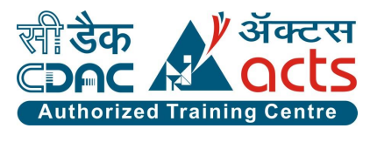

Project Name: PocketShala

Branch: PG-DAC September-2021

Documentation On

“**PocketShala**”

PG-DAC September-2021

Submitted By :

**Group No: 18**

• Ankit Suresh Sawant **210943120014**

• Shripad Hemant Bhagat **210943120021**

• Puneet Subhashchandra Gupta **210943120076**

• Uzeena Azeem Mhaskar **210943120114**

**Table of Content**

### Introduction 3

#### Problem Definition 3

* 1. Objective of Project 3

1. **Feasibility Study. 4**
2. **Analysis. 5**
   1. Existing System. 5
   2. Proposed System 5
   3. Software Requirement Specification 5
3. **Design** . **7**
   1. ER diagrams .7

### Implementation .. .8

#### **5.1** Modules………………………………………………………………………………...8

**5.2** Module description……………………………………………………………………..8

**5.3** Introduction of technologies used………………………………………………………12

1. **Test cases. 15**
2. **Screenshots of Webpages 17**
3. **Conclusion 20**
4. **Future Enhancement 27**

**10. Bibliography 28**

1. **Introduction:**
   1. **Problem Definition:**

Due to pandemic situation,the kids are coming in high risk group and government has prohibited their offline schooling and at their age don’t understand some things.At home the kids can enhance there skill and every parent focuses on this issue, they want their kids to start thinking creatively and enjoy learning at home by keeping that in mind, we are providing them fun with learning. For Class 1 to7 we will be providing curriculum subjects to learn while being at home which will include flashcards,worksheets,etc. It will be helpful for children to learn while having fun that will increase their logical thinking ability, creativity and grasping power.

* 1. **Objective of Project:**

This projects aims to develop an online homeschooling for kids with the goal so that it is very easy to

learn the things that your kids love to do. With the help of this website you can carry out fun learning

and also buy kits for your child according to class and category.You simply require a PC or a laptop and

to make your kids learn while having fun.To get to this pocketshala website all the children or there

parents will need to have a email and password to login and proceed with learning . The login credentials

for pocketshala are under high security and nobody will have the capacity to crack it easily. Upon

successful login the customers(children/parents) can purchase a wide range of products such as drawing

kits,crafting,colouring, etc. Not just these, kids can also learn through the worksheets according to there

class. And of course you will get your requested ordered items at your door step.You can pick your

favourite items from variety of products looking at cost and quality. We have only provided cash

on delivery payment .

1. **Feasibility Study:**

**2.1 Performance**

Easy tracking of records and updating can be done. All the requirements relating to performance characteristics of the system are specified below.

1) Number of Terminals: The software makes use of database that will reside at the server, while the front end will be available online to computers for children’s and parents.

2) Number of Users: The number of users may vary, as this software application is public.

Dynamic Requirements specify constraints on the execution characteristics of the system. They typically include response time of the system.

**2.2 Reliability**

The software will not be able to connect to the database in the event that if the home network fails or in the event of the server being down due to a hardware or software failure.

**2.3 Availability**

The software will be available only to authorized users of the children’s and parents to learn new things, buy products based on categories, admin to add an update products,categories and classes, and to view the customer details,orders,etc.

**2.4 Security**

The software should be handled only by the administrator and authorized users. Only the administrator has right to assign permission like creating new accounts and generating password. Only authorized users can access the system with username and password.

**2.5 Portability**

The Software is a web-based application and is built in Springboot and MYSQL so it is platform independent and is independent of operating system.

**2.6 Financial Feasibility**

In this case the main objective is to focus on cost-effective service. Always it is aimed at how the cost should be reduced and how the productivity can be increased. Economic feasibility leads to: **1**. Easy to Use system **2**. Simple and easy to understand User-Interface **3**. Low-cost Maintenance

1. **Analysis**

**3.1 Existing System:**

This existing system of homeschooling has several disadvantages. It requires lots of time to travel to particular school to learn new things. Since both parents are leading busy life nowadays, time means a lot to everyone. Also there are expenses for travelling from home to school. More over the schools are not opened 24*7*365 and also due to pandemic, opening of schools were prohibited.Hence parents have

to adjust their time with the schools time. In order to overcome these, we have a e-commerce solution, i.e one place where we can get all required fun learning/products(kits),worksheets online.

**3.2 Proposed System:**

The proposed system helps in building a website to buy, sell products and provide worksheets ,flashcards online using internet connection. Purchasing of kits online, user can choose different products based on categories.This system only has payment option as cash on delivery.The system also provides home delivery for delivering the purchased products.

**3.3 Software Requirement Specification:**

**3.3.1 Hardware and Software Requirements (Minimum):**

**Hardware:**

1. Intel i3 processor 3rd generation or later

2. 4 GB ddr3 ram.

3. Windows 7 Home edition or later.

4. 200 GB Sata HDD Space

5. Data Connection 200 kbps

**Software:**

1. Spring tool suite4
2. MySQL 8.0 with Workbench 8.0
3. Google Chrome version 79.0
4. Apache Tomcat Server 8.5
5. Maven Dependencies
6. Visual Studio code

**3.3.2 Functional Requirements**

**1. Customer Module •**

(i)Customer can login or register. •

(ii)Customer can access through class and categories for learning purpose.

(iii)Customer can see products according to their requirements.•

(iv)Add products to cart. •

(v)Buy products selected in the cart.

(vi)Can contact us for queries.

(vii)Give ratings to the product.

**2. Admin Module** •

(i)Admin can login. •

(ii)Track customers activities and data.

(iii)Admin can add products for sell.•

(iv)Add class,category and product. •

(v)Generate orders report.

**3.3.3 Non-functional Requirements**

(i) The website should use proficient design, look and feel and color scheme.

(ii) 24X7 availability.

(iii) Better component design to get better performance at peak time.

(iv)Secure access to consumer’s confidential data. •

(v)Users will have no limitations for accessing the application through Internet.

(vi)Being a public website, the site must follow general guidelines for menus, navigation and other actions provided on the screens.

(vii)The system should be designed in such a manner that user will be able to complete all tasks in minimum number of steps.

1. **Design:**

**4.1 ER Diagrams**

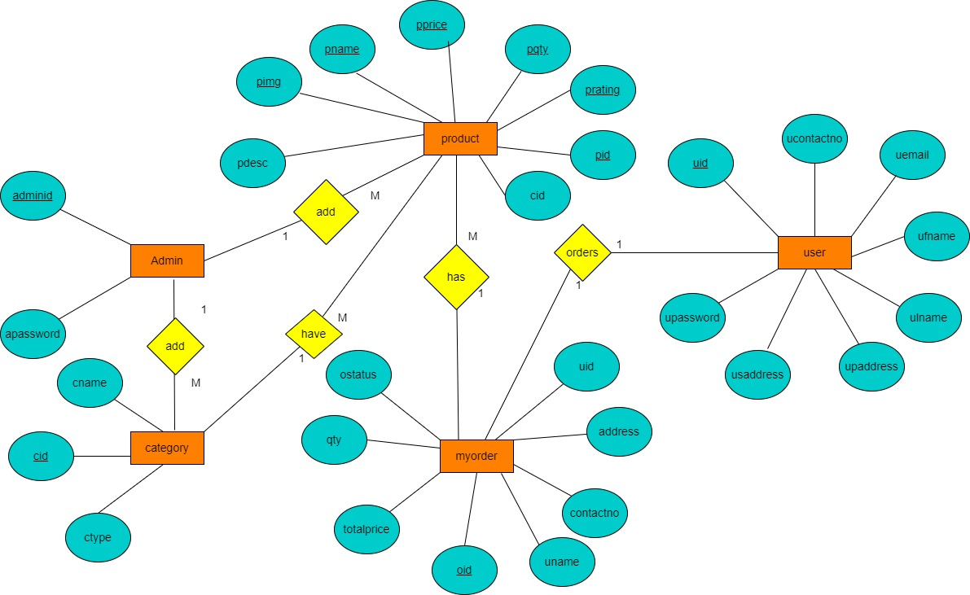

1. **Implementation:**

**5.1 Modules:**

**1)Customer**

**2)Admin**

**3)Class**

**4)Category**

**5)Product**

**6)Order**

**7)Payment**

**8)Bill**

**5.2 Modules Description:**

**5.2.1. Customer Module •**

* + - Customer is the user of system who wants to learn new things by his/her grade and according to category purchase the products.
    - He/She is also able to buy products added by admin.

## Account Creation Process

Pocketshala urges to create the account before actually buying a product. So, Pocketshala should provide the function which makes customer create new account.

When customer creates new account, the function demands information described as below.

1. Login information
2. Contact Details

* The Login information

The Login information consists of some items described as below.

1. CustomerId
2. First Name
3. Last Name
4. E-mail Id
5. Password

All fields are compulsory demanded.

1. CustomerId

The CustomerId should be unique. If the CustomerId corresponds with not case- sensitive to other which is previously registered, the CustomerId should not be registered as an account.

2. Password

The Password has constrains which makes the Password consists of more than or equal 8 and less than or equal 16 characteristics including characters described as below.

* 1. Numeric figure (at least one)
  2. Capital alphabet (A-Z)(at least one)
  3. Small alphabet (a-z)(at least one)
  4. Special character (#, $, %, &, etc.) (at least one)
* Contact Details

The Contact Detail consists of some items described as below.

1. Permanent Address
2. Shipping Address
3. Contact Phone No

All items are compulsory demanded.

1. Permanent Address

Permanent Address should be filled.

1. Shipping Address

Shipping Address should be filled by customers if location is different.

## Login Process

* + - * Pocketshala always checks customer authentication before using itself except when a new account is successfully created.
      * The user authentication demands EmailId and Password. The EmailId and the Password should be checked in following way.

1)The EmailId and the Password should be existed and correct.

2) If the EmailId and the Password are not equal to what the customer has registered, the customer authentication cannot be provided.

## Forgot Password Process

* + - * When customer forgets their Password, the recovery method should be provided by Pocketshala.

## Search Product

* Search conditions are described as below.

1)Product Name

2)Category

* Customer can search the product of his/her own choice and result will be displayed on the browser.

1. **Navigate through Class and Category**

* Customer according to his age can select the class and category and learn the things.

## Add Product to Cart

* Customer can add products into the cart of his/her own choice. Products in the cart will remain in the cart till he actually buys the product or explicitly removes it. Customer can add as many products as he wants.
* Customer can see total products and total prize of the products added into the cart**.**

## Remove Product from Cart

* Customer can remove the products from his cart.
* Total price and count(products) will be changed as soon as customer removes the product/s from his cart

## Buy Products

* Before buying the product/s customer needs to login/register.
* Selected product/s first will be added into the cart and then further proceed for the checkout.
* Products which are present in the cart will be considered as a final choice of the customer.

## Checkout/Billing

* Total products count and total amount will be displayed before the checkout. After checkout success message will be shown to the customer.
* Successful message will be send to the customer on contact no. and email ID with the purchase details.

**5.2.2. Admin Module** •

Administrator should be responsible for following activities**,**

## Login Process

* + - * Pocketshala always urges Admin authentication before using itself except when a new account is successfully created.
      * The user authentication demands AdminId and Password. The AdminId and the Password should be checked in following way.
  + The AdminId and the Password should be existed and correct.
  + If the AdminId and the Password are not equal to what the admin has registered, the admin authentication cannot be provided.

## Add category of Product

* Admin should able to add new category for displaying product.
* In order to display the products more effectively, it needs to be categorized.
* For that, admin has to add some categories so that he can add the products according to the category.
* Also, if some categories remain empty for long time(no products present for that category) admin should able to delete that particular category.

## Add products

* + Admin should be able to add new products.
  + Admin should be able to add,update product name,description,price,quantity of product
  + Admin should be able to delete the products which are old or out of stock.

## Add class

* + Admin should be able to add,update and delete the classes.

## View records of customers

* + - * Admin can see records of Customers , which includes

1. Registration details
2. Total Count of customers
3. Information about products and orders

## View records of orders

* + - * Admin can see records of orders , which includes

1. Order id
2. Order date

c. Price

d. Shipping address

e. Order status

**5.3 Introduction of technologies used:**

**1) MySQL**

MySQL is a fast, easy-to-use RDBMS being used for many small and big businesses. MySQL is developed, marketed and supported by MySQL AB, which is a Swedish company. MySQL is becoming so popular because of many good reasons −

* + MySQL is released under an open-source license. So you have nothing to pay to use it.
  + MySQL is a very powerful program in its own right. It handles a large subset of the functionality of the most expensive and powerful database packages.
  + MySQL uses a standard form of the well-known SQL data language.
  + MySQL works on many operating systems and with many languages including PHP, PERL, C, C++, JAVA, etc.
  + MySQL works very quickly and works well even with large data sets.
  + MySQL supports large databases, up to 50 million rows or more in a table. The default file size limit for a table is 4GB, but you can increase this (if your operating system can handle it) to a theoretical limit of 8 million terabytes (TB).
  + MySQL is customizable. The open-source GPL license allows programmers to modify the MySQL software to fit their own specific environments.

1. **Springboot**

Spring Boot is an open source Java-based framework used to create a micro Service. It is developed by Pivotal Team and is used to build stand-alone and production ready spring applications.

Spring enables you to build applications from “plain old Java objects” (POJOs) and to apply enterprise services non-invasively to POJOs. This capability applies to the Java SE programming model and to full and partial Java EE.

### Advantages

Spring Boot offers the following advantages to its developers −

* Easy to understand and develop spring applications
* Increases productivity
* Reduces the development time

### Goals

Spring Boot is designed with the following goals −

* To avoid complex XML configuration in Spring
* To develop a production ready Spring applications in an easier way
* To reduce the development time and run the application independently
* Offer an easier way of getting started with the application

**Features of Springboot**

* It provides a flexible way to configure Java Beans, XML configurations, and Database Transactions.
* It provides a powerful batch processing and manages REST endpoints.
* In Spring Boot, everything is auto configured; no manual configurations are needed.
* It offers annotation-based spring application
* Eases dependency management
* It includes Embedded Servlet Container

1. **React**

ReactJS is a **declarative**, **efficient**, and flexible **JavaScript library** for building reusable UI components. It is an open-source, component-based front end library which is responsible only for the view layer of the application. It was initially developed and maintained by Facebook and later used in its products like WhatsApp & Instagram.

### Features of React:

* JSX (JavaScript Syntax Extension)
* Virtual DOM
* One-way data binding
* Performance
* Extensions
* Conditional statements
* Components
* Simplicity

1. **Test cases**

|  |  |  |  |  |
| --- | --- | --- | --- | --- |
| **Test Case ID** | **Test Case** | **Expected Result** | **Actual Result** | **Pass/Fail** |
| TC_01 | Enter URL for PocketShala | URL working(success) | Success | **Pass** |
| TC_02 | Test case for working of admin login page | 1. AdminId and password valid (Login Success) 2. AdminId and password invalid (Login Unsuccessful) 3. AdminId and password invalid (Login Unsuccessful) | Login Successful  Login Successful  Login Unsuccessful | **Pass**  **Fail**  **Pass** |
| TC_03 | Test case for working of customer login page | 1. EmailId and password valid (Login Success) 2. EmailId and password invalid (Login Unsuccessful) 3. EmailId and password invalid (Login Unsuccessful) | Login Successful  Login Successful  Login Unsuccessful | **Pass**  **Fail**  **Pass** |
| TC_04 | Test case for navigating through class | Navigation Successful | Success | **Pass** |
| TC_05 | Test case for adding one item to the cart | Add one product in cart | Add successful | **Pass** |
| TC_06 | Test case for adding the new products into the cart and whether the count is increasing | Adding new products and to check count is increasing | New products added and count increasing | **Pass** |
| TC_07 | Test case to check whether the transaction/billing is done properly | Order generated bill is generated | Billing Successful | **Pass** |

1. **Screenshots of Webpages**

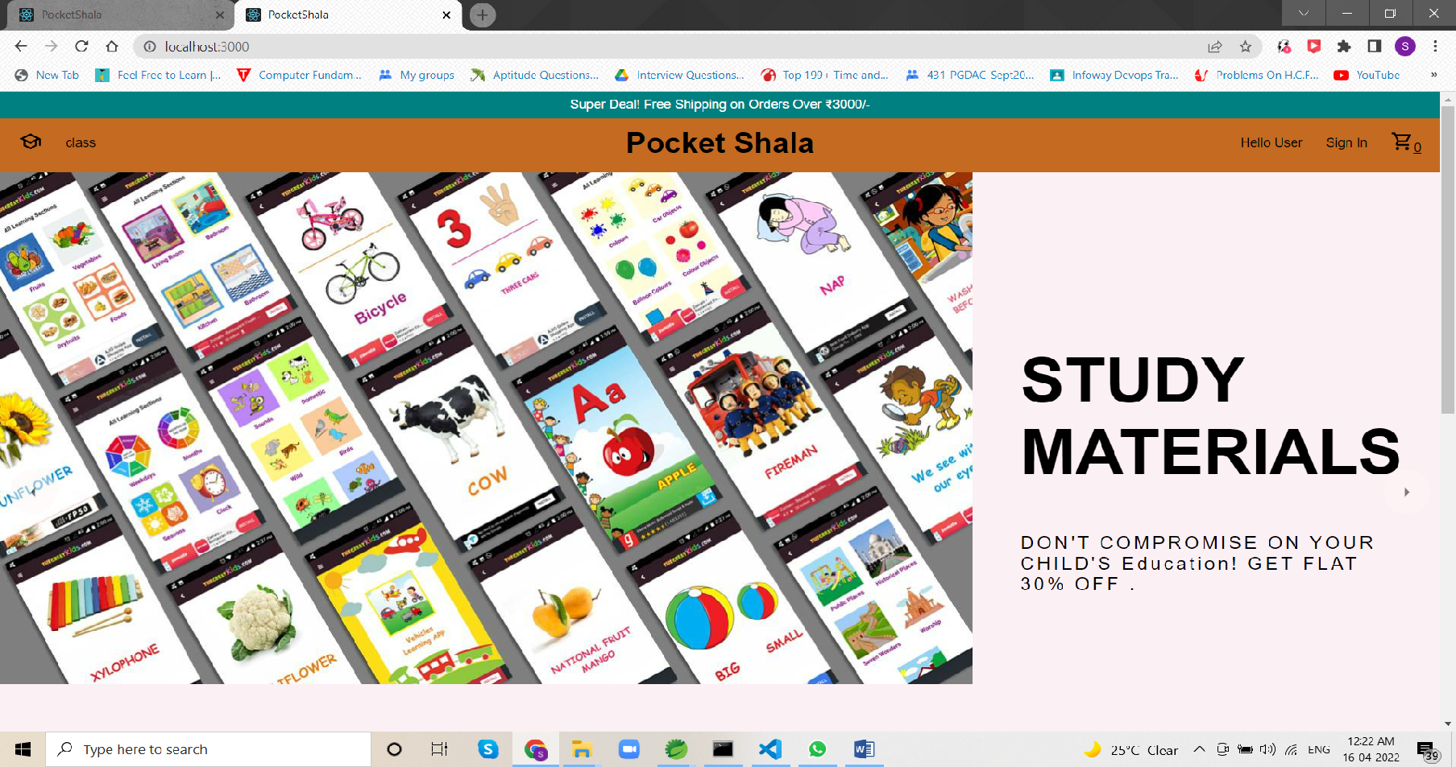

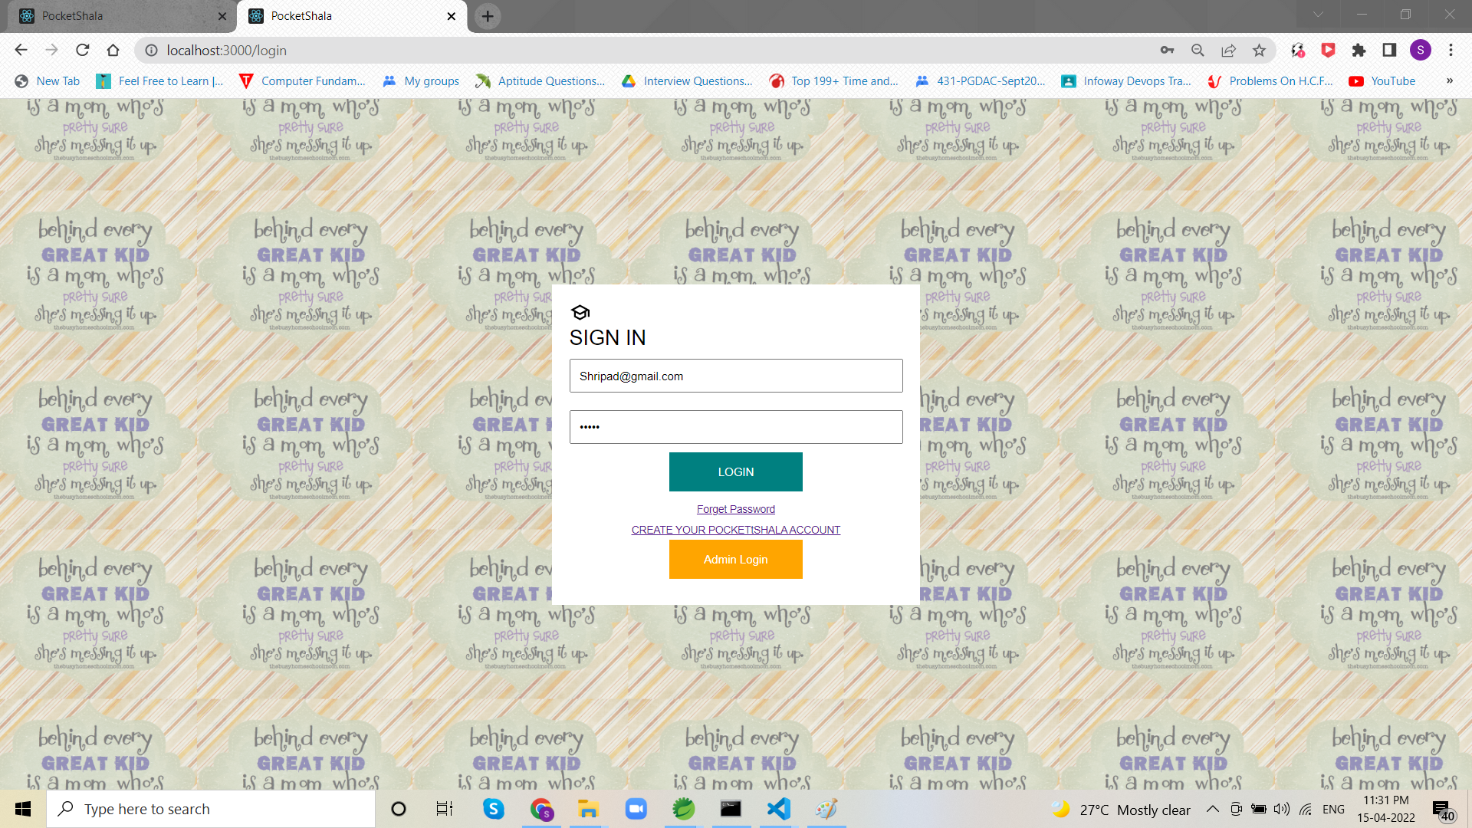

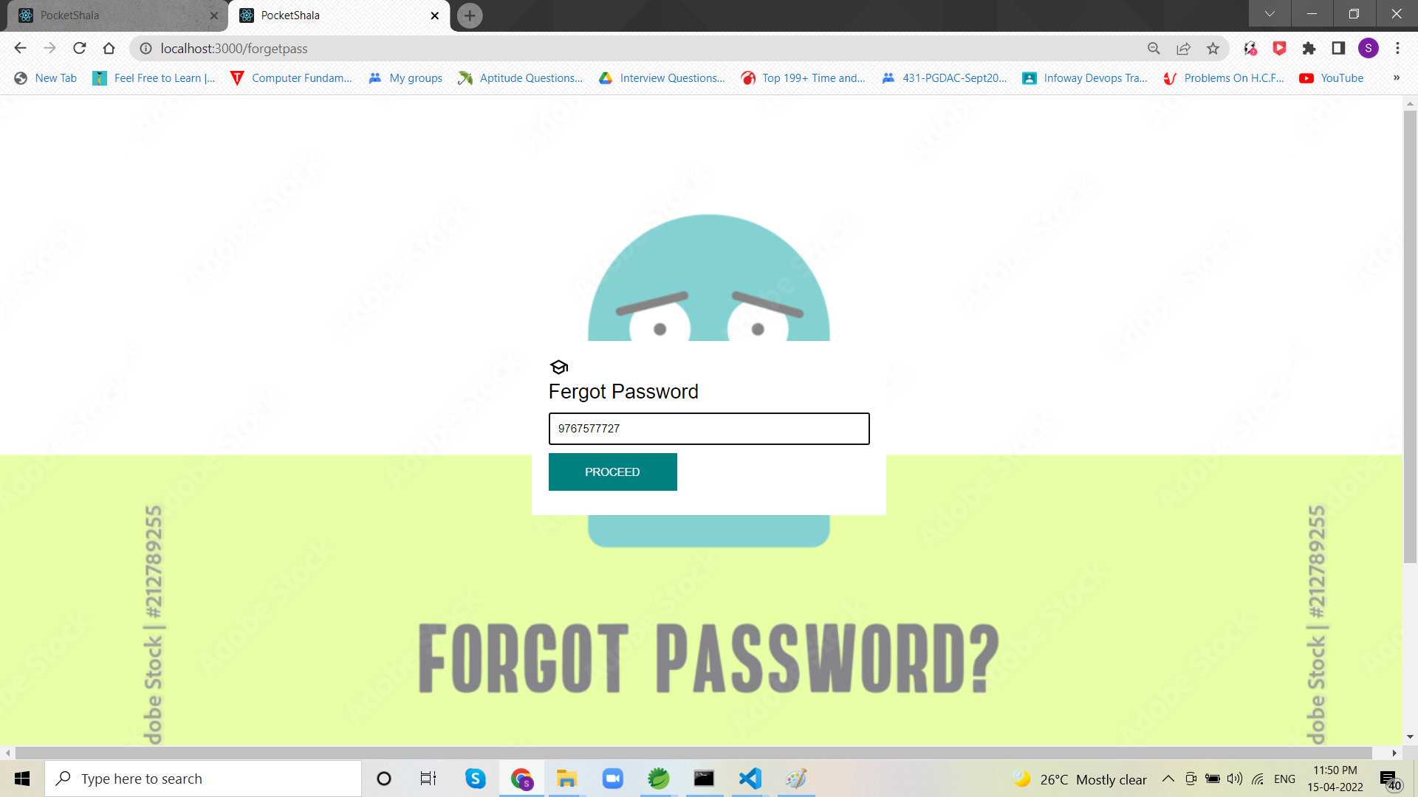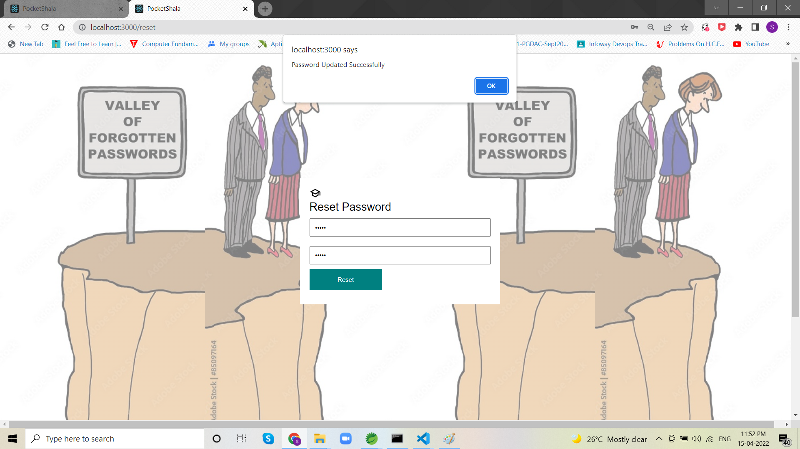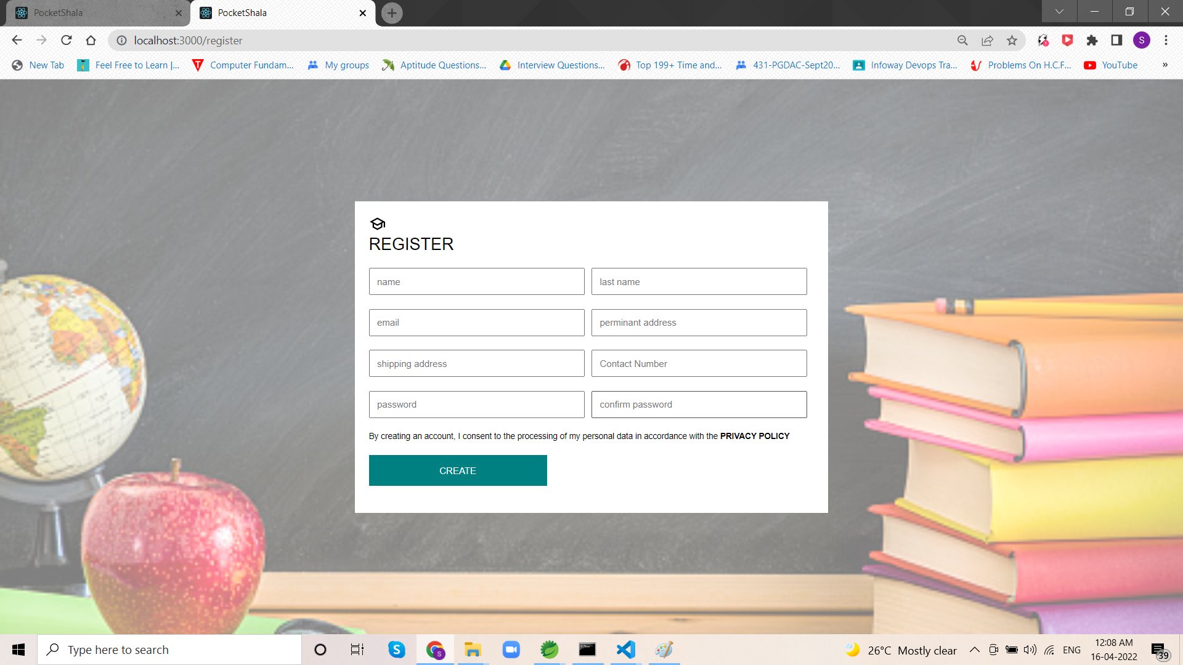

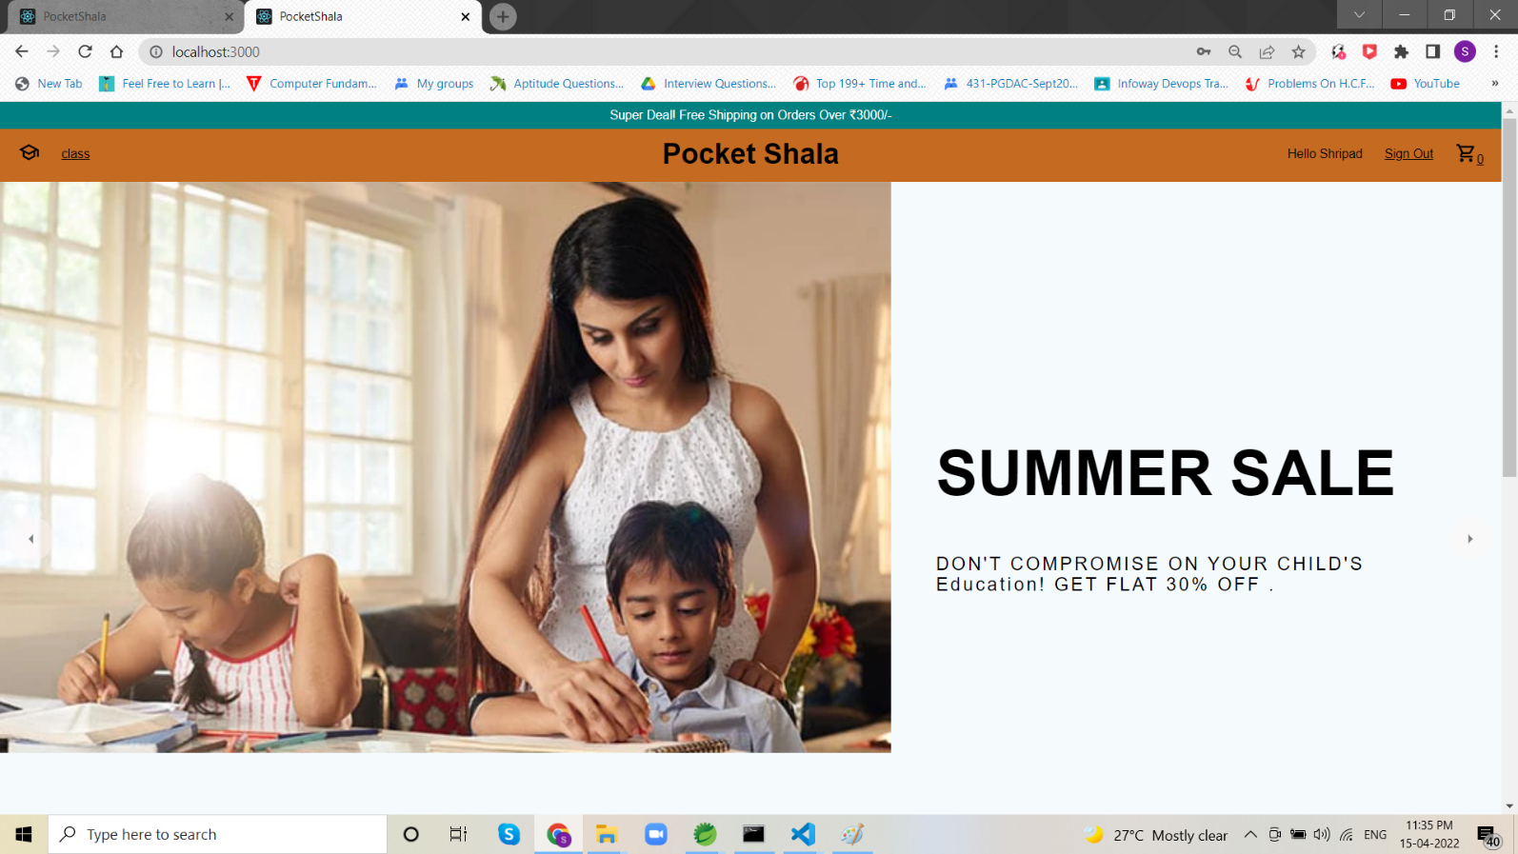

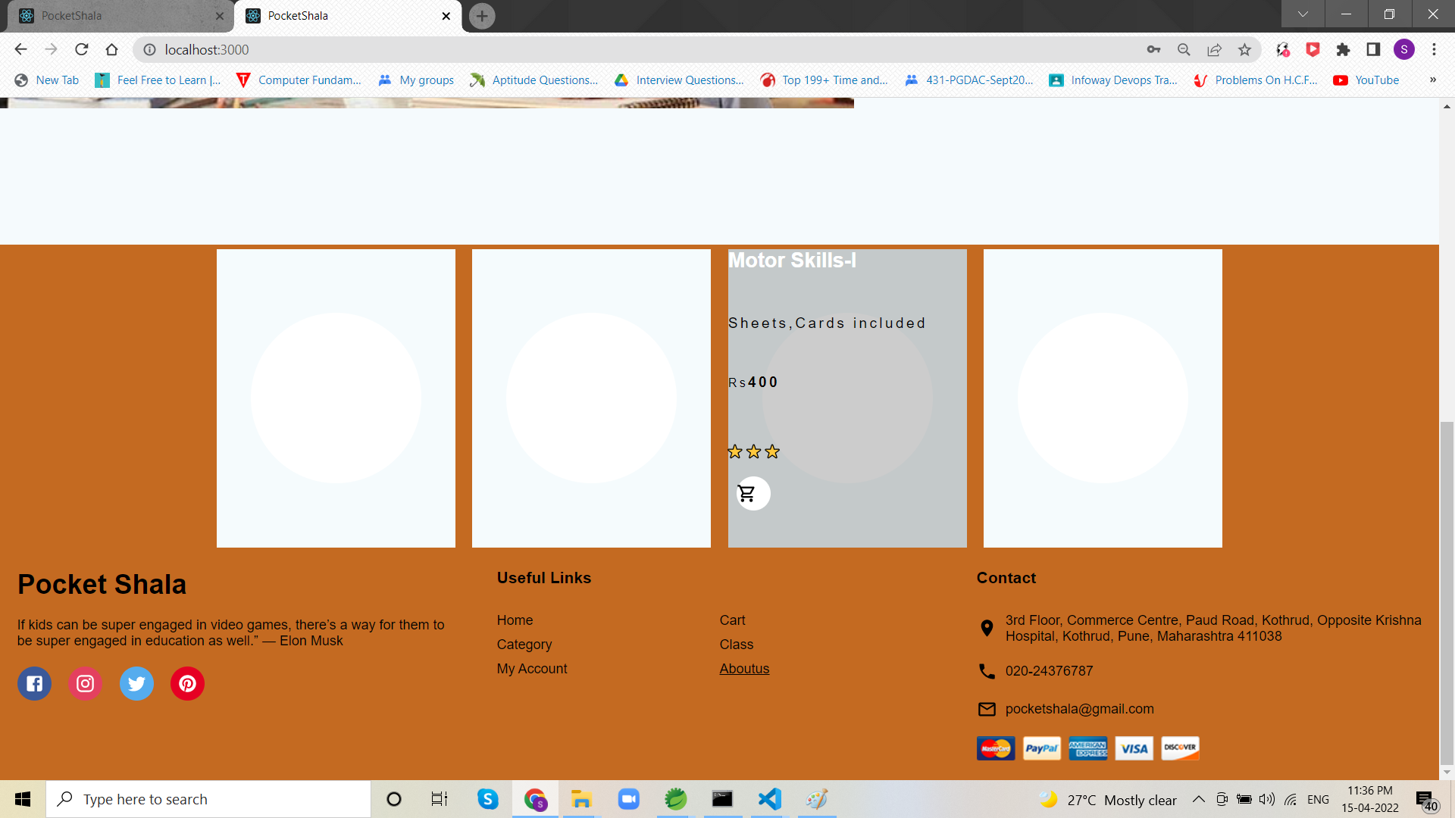

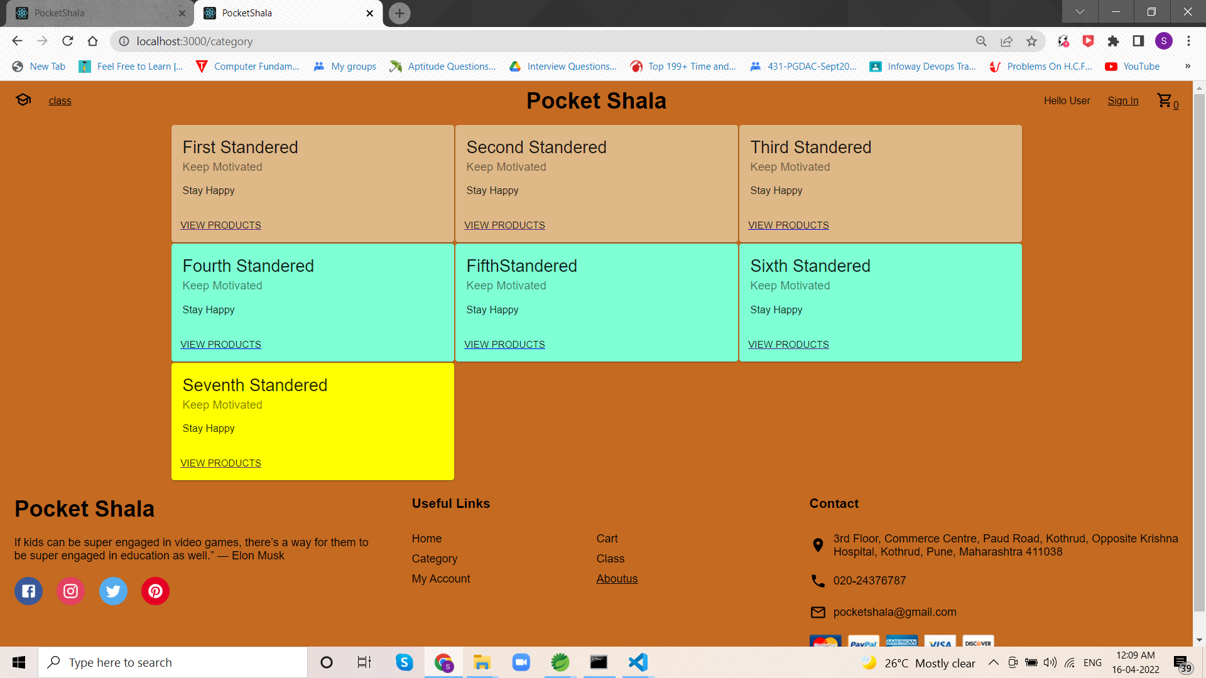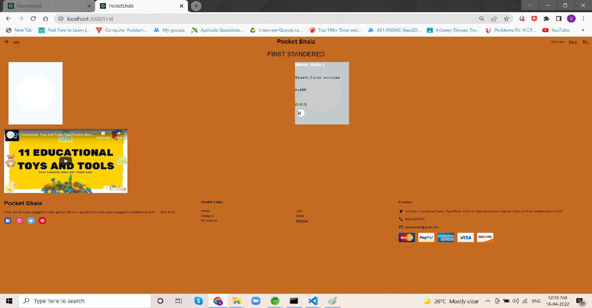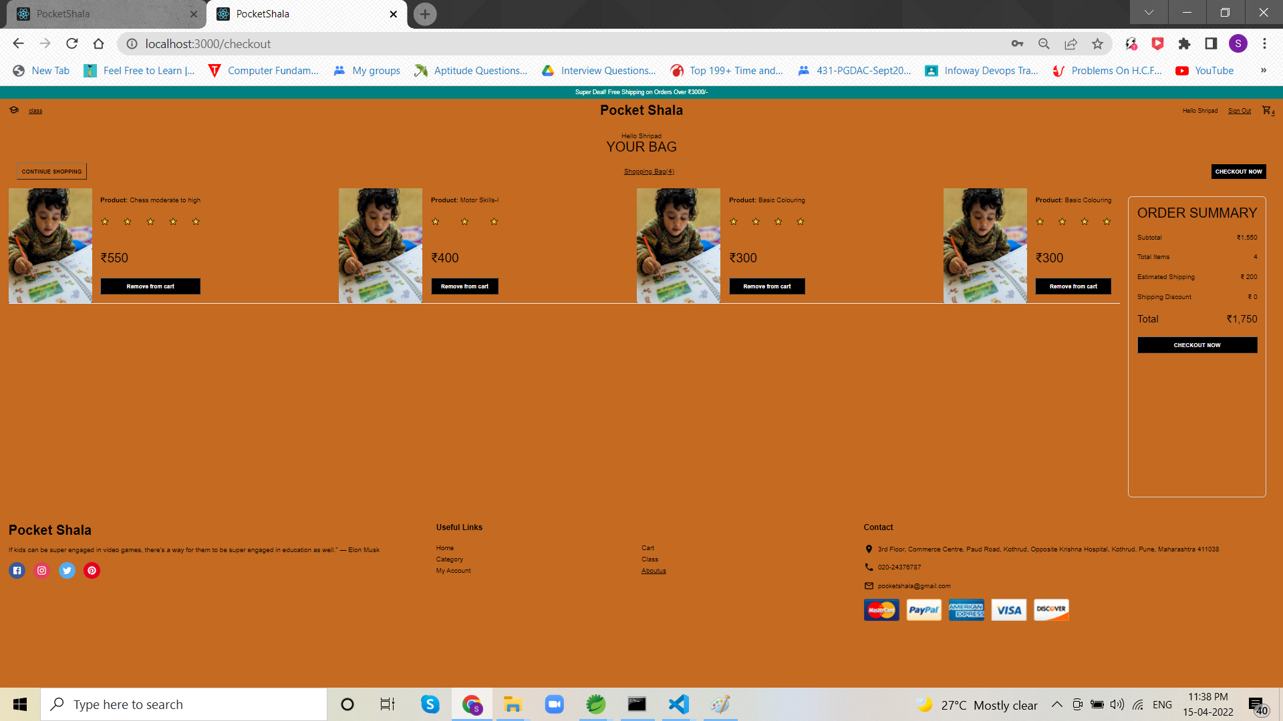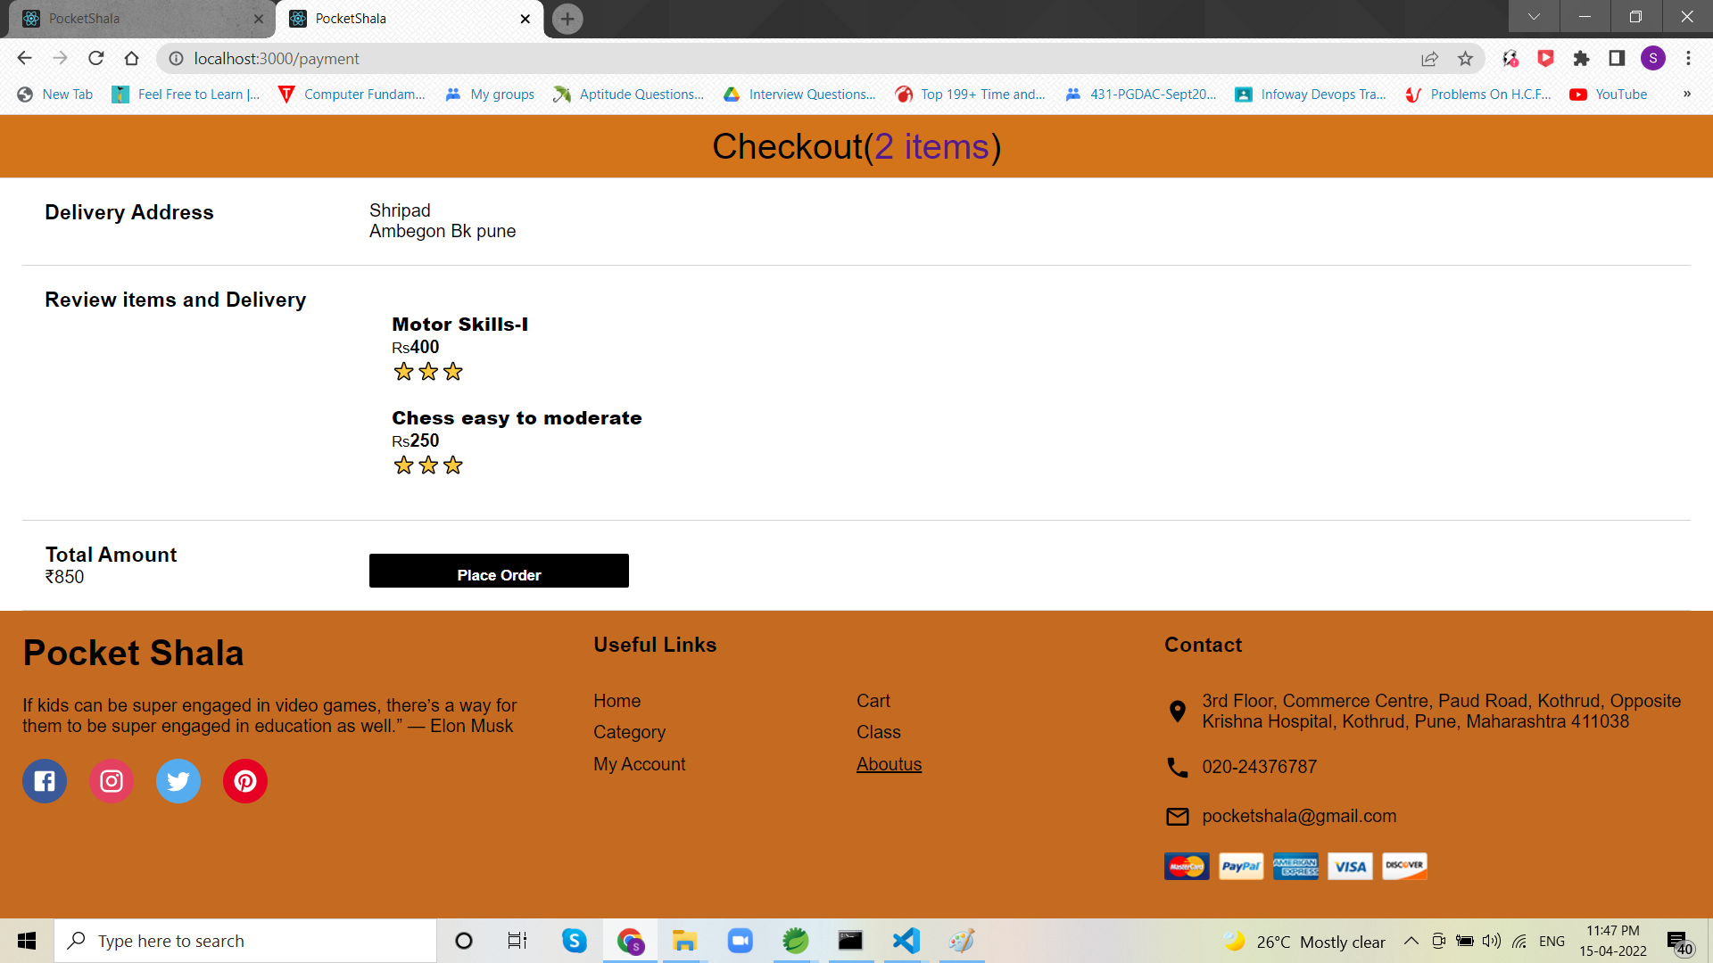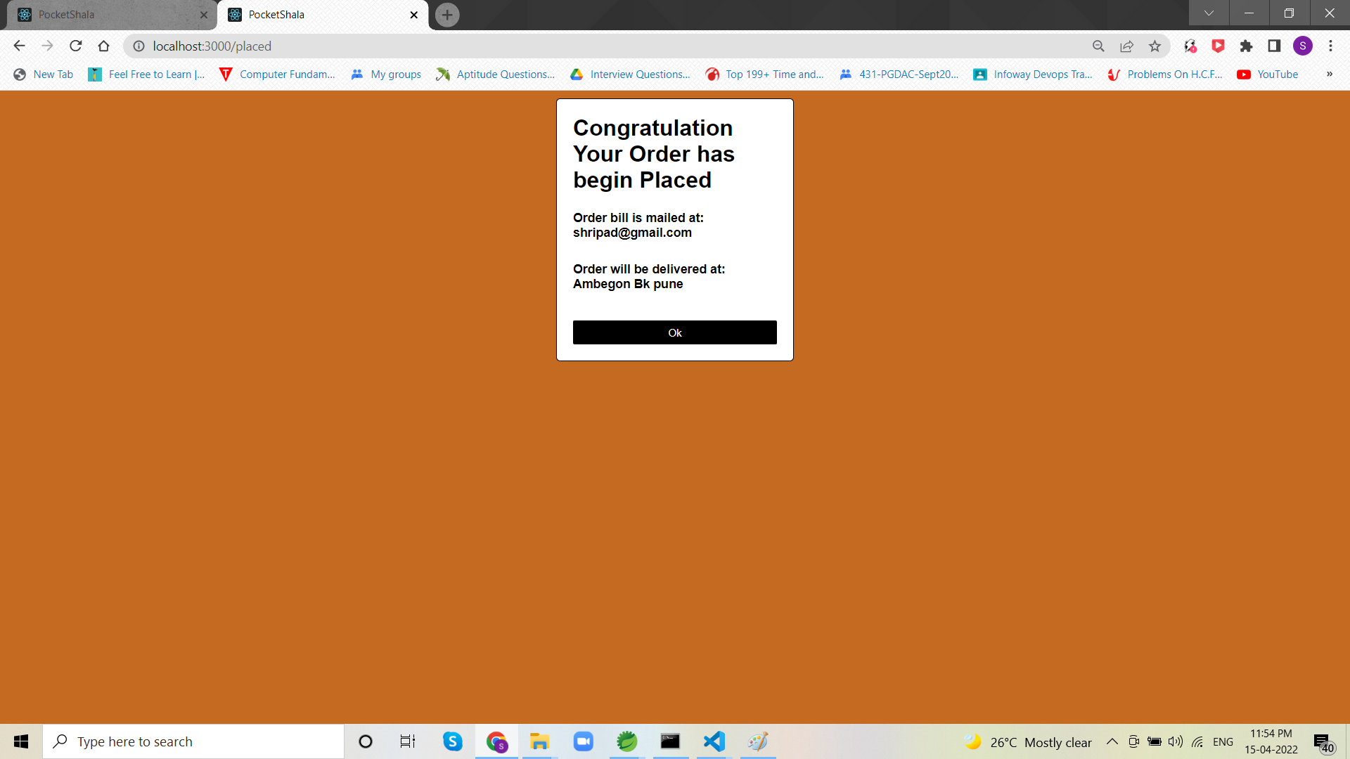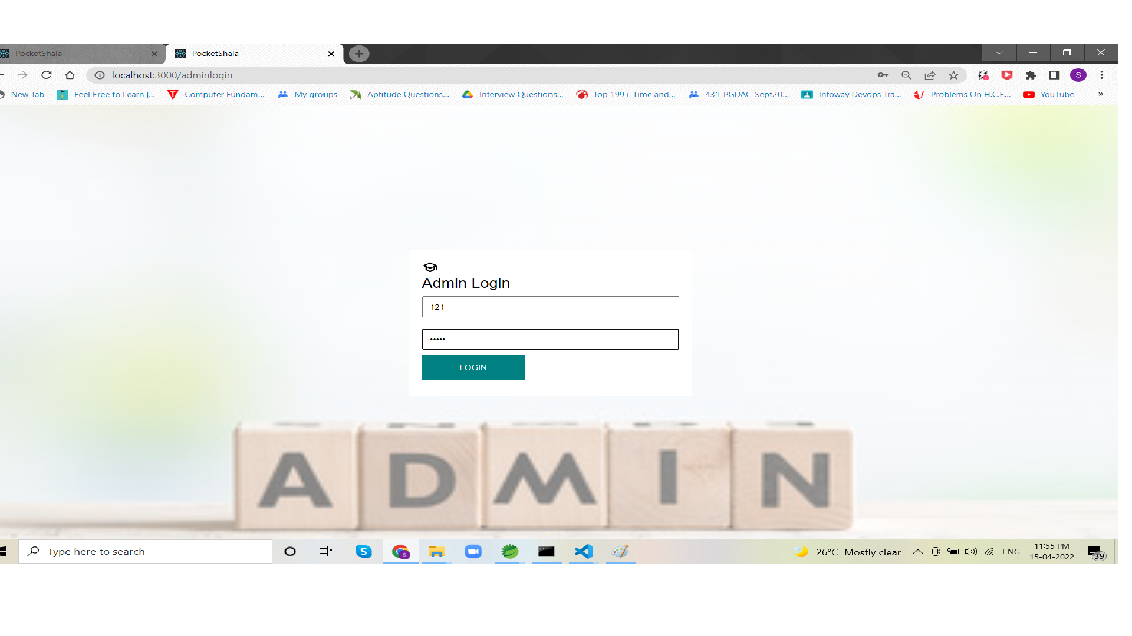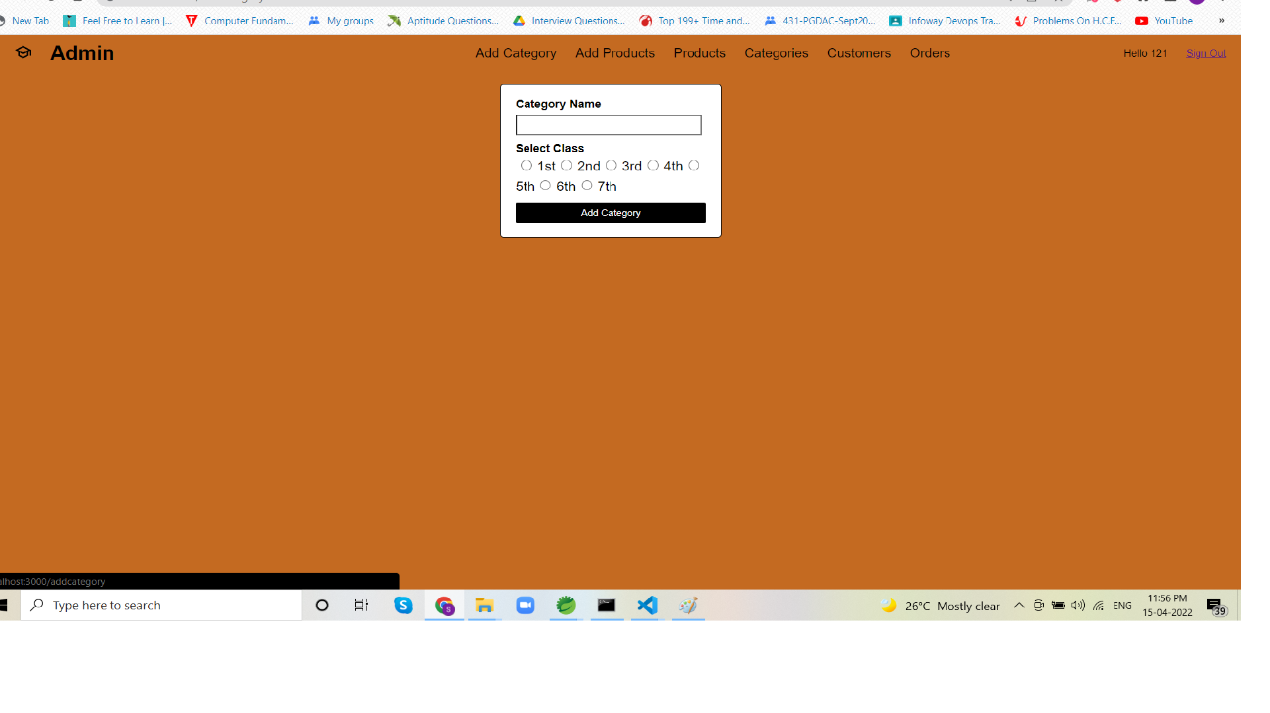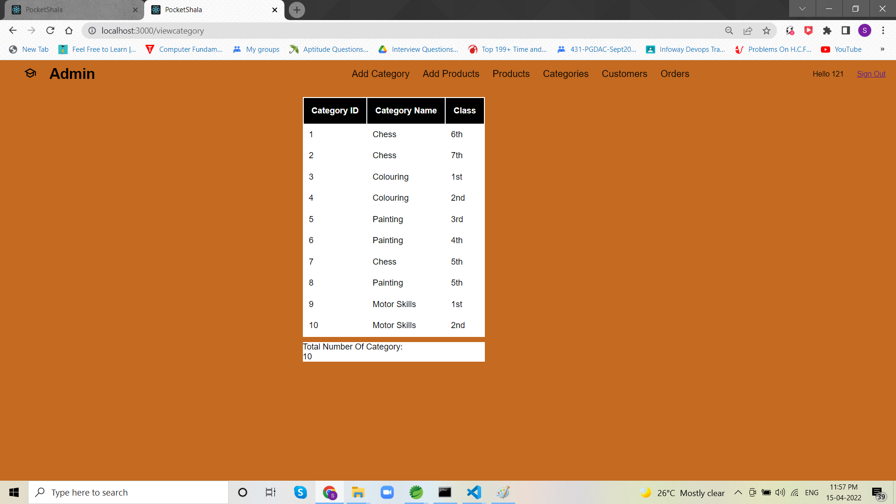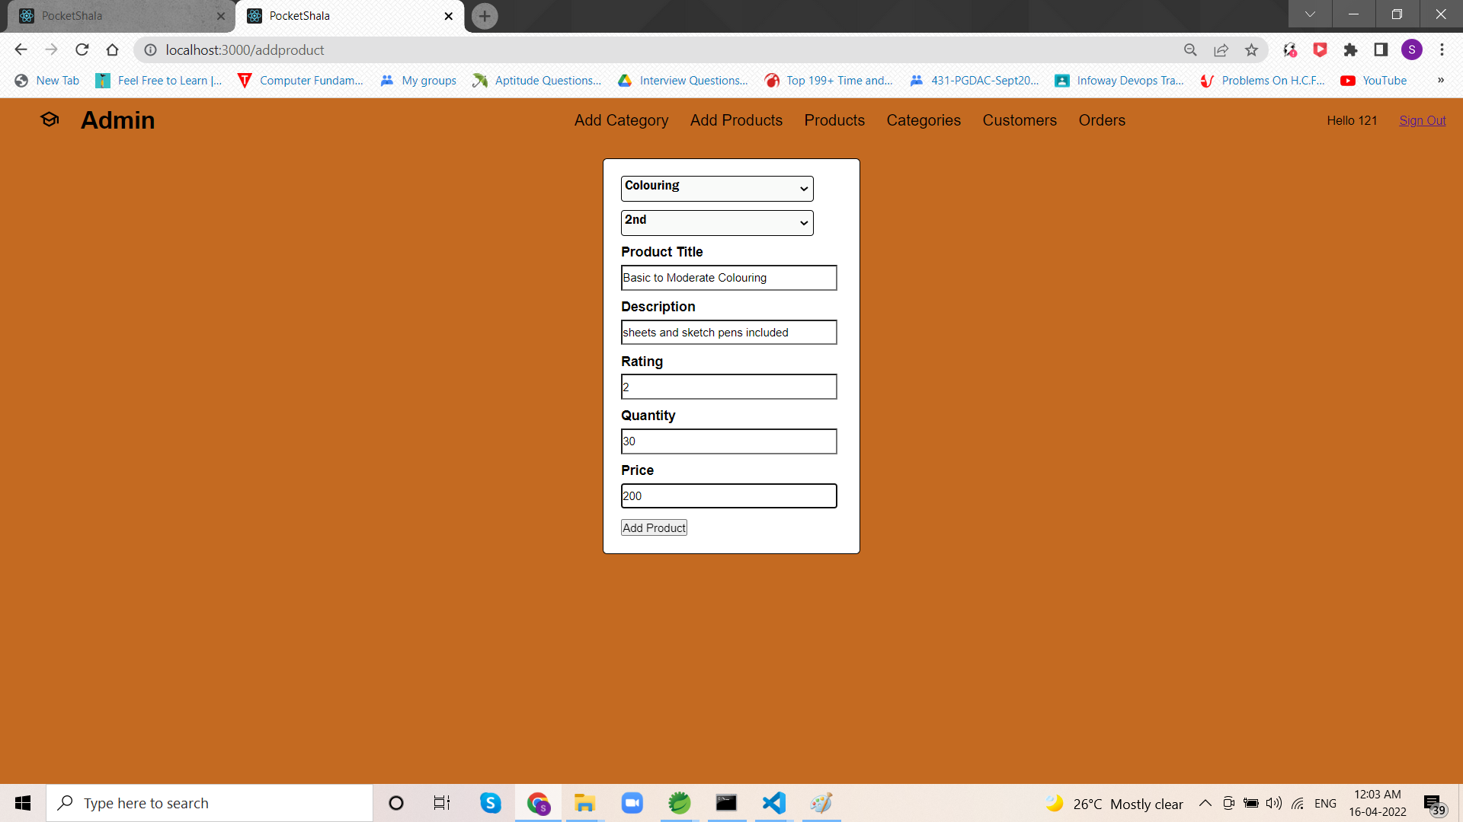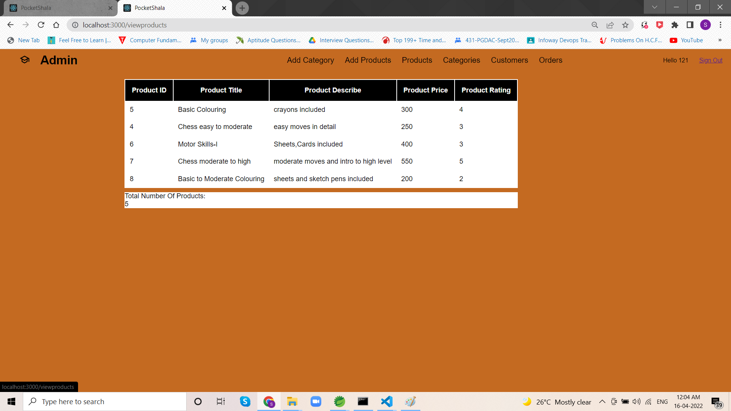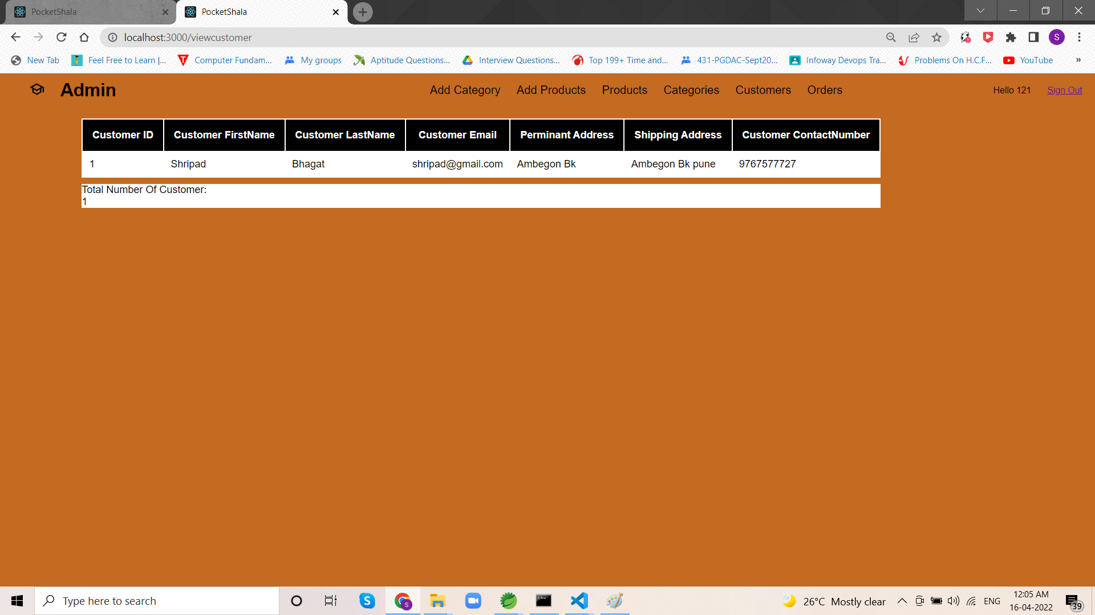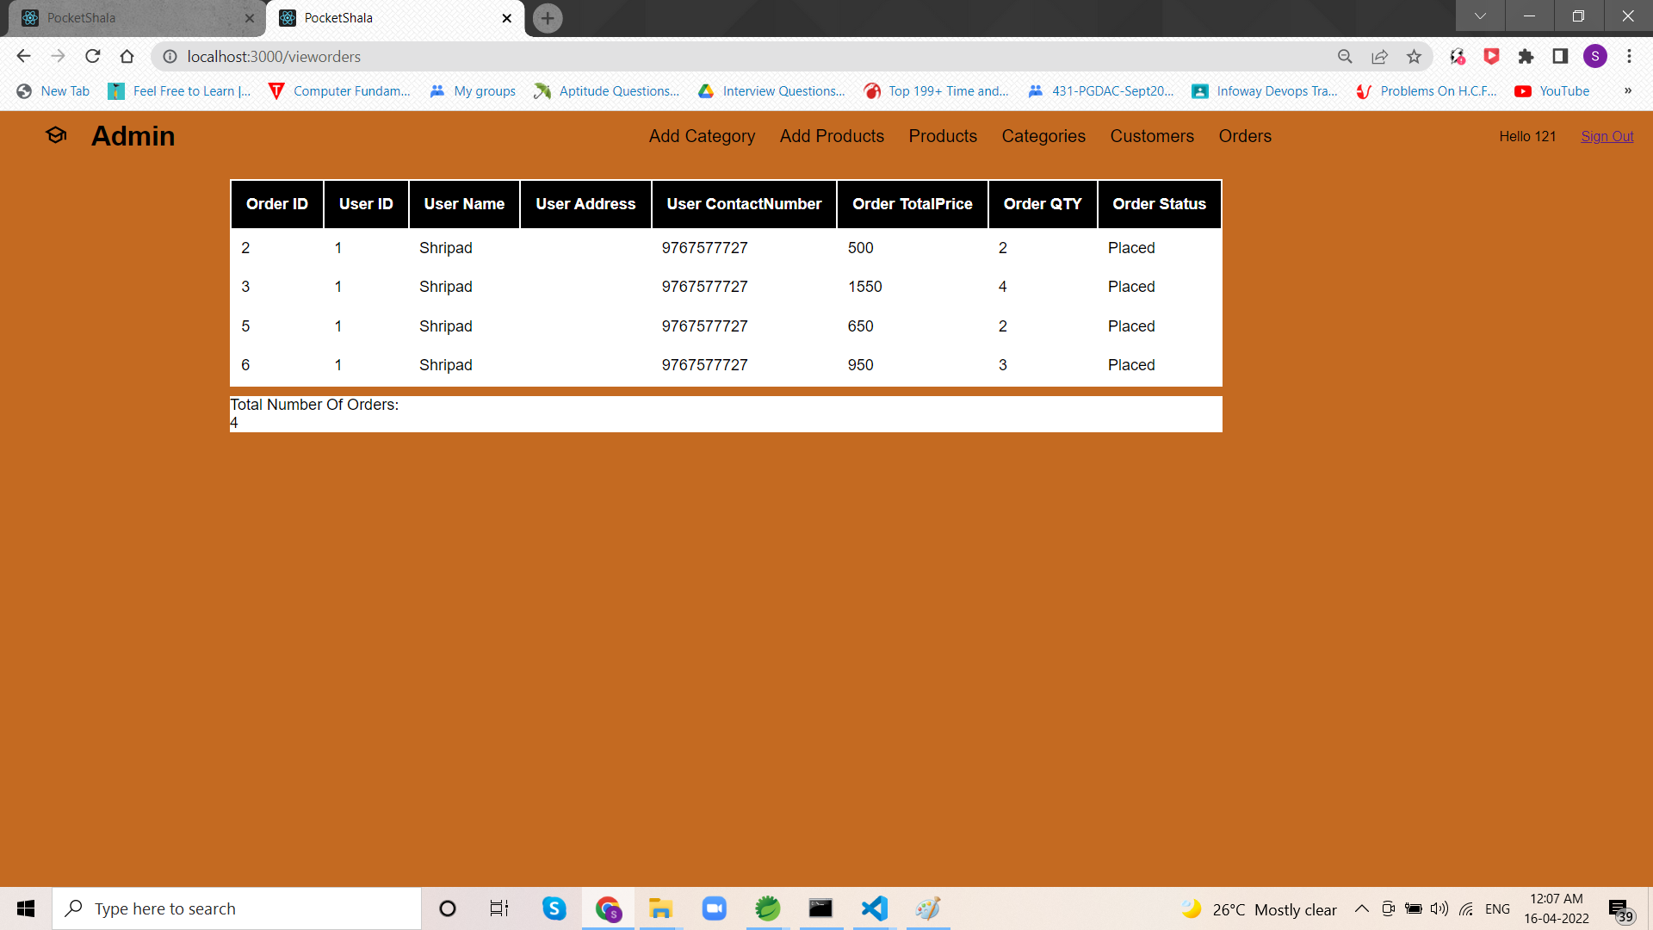

1. **Conclusion**

Pocketshala provides a platform for kids to learn new things by having comfort at home. A single platform to sell products(kits)and to buy by customers. Our System provides a very user-friendly platform where Customers can see and buy various types of products according to category and class which are added by added by admins. Admin have overall control over the website and can view records of customers. Hence the above points describe briefly the general framework, detail description of website and programming skills used for entire designing of website. The website ‘pocketshala’ is most efficient for users. It is easy to use and can be handled by everyone. The graphics used make it beneficial for illiterate people to understand the objective. I hope this will be a first and a great choice for everyone in the field of homeschooling.

1. **Future Enhancement**

In future we will be adding old used toys(donation) section for those customers who can’t afford them along with that we will be adding SMS to track the order.

1. **Bibliography**
2. <https://www.tutorialspoint.com/mysql/mysql-introduction.htm>
3. <https://www.w3schools.com/mysql/>
4. <https://www.tutorialspoint.com/spring_boot/spring_boot_introduction.htm>
5. <https://www.geeksforgeeks.org/what-are-the-features-of-reactjs/>
6. <https://www.javatpoint.com/reactjs-tutorial>
7. <https://webandcrafts.com/blog/react-js-features/>
8. <https://thegreatkids.com/>
9. <https://in.ixl.com/>